**AWS :**

**S3 multi-region access point lab:-**

Step 1: go to aws management console and move to s3 console

Step 2:create two buckets in different regions and rest settings kept by default

Step 3 : click on the “multi-region access point” present on the left side of the s3 dashboard and create a multi-region access point.

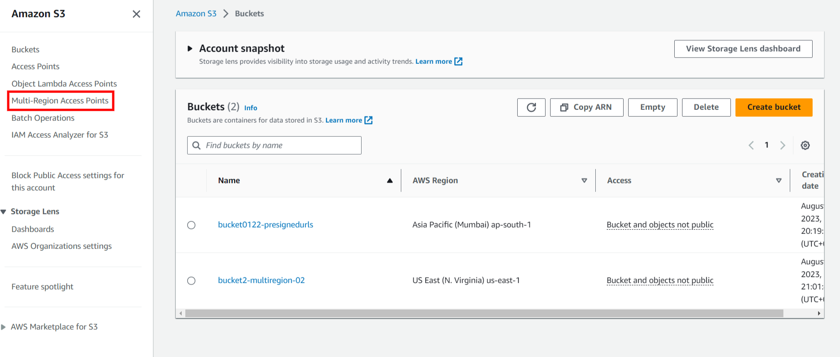

Step 4: To create a multi-region access point ,name the access point and select both the buckets and block all public level access and then click on “create multi-region access point”.

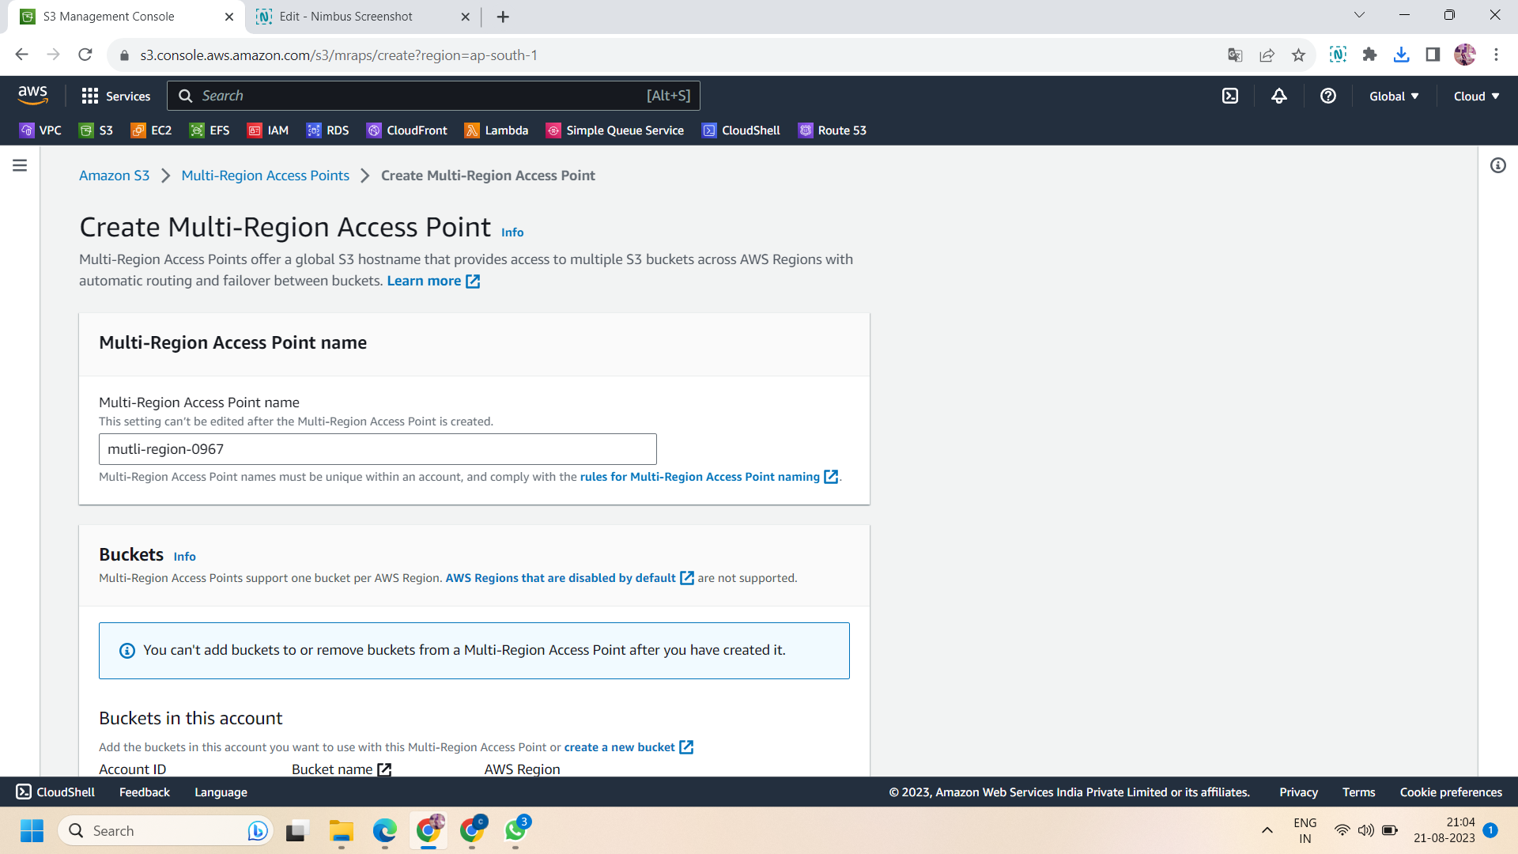

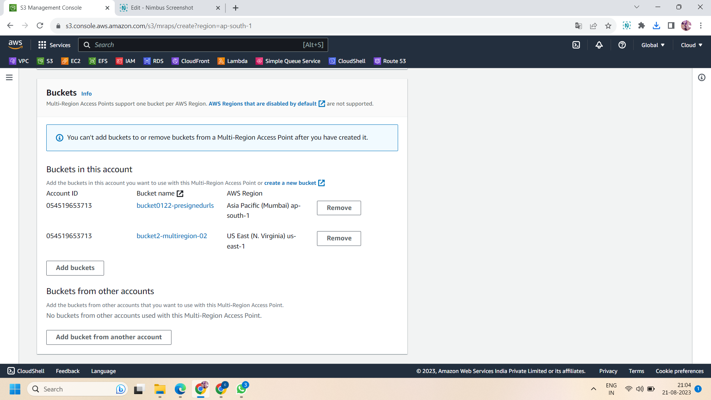

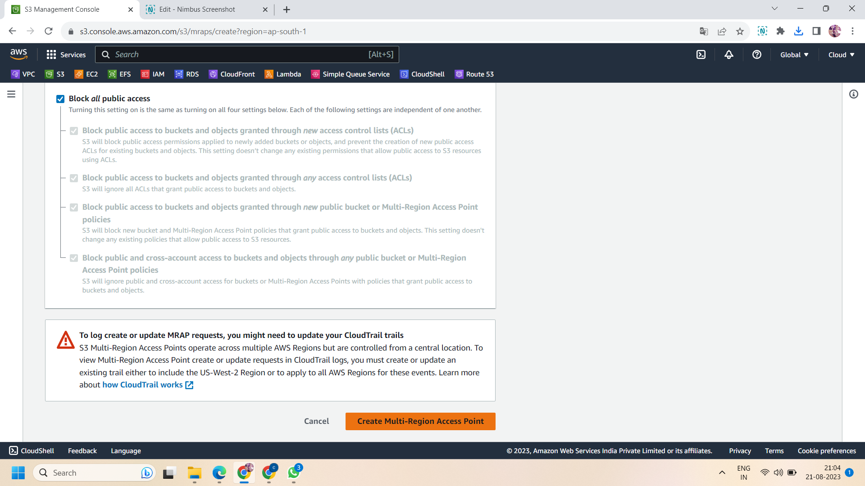

Step 5:It will take approx 30 minutes to create the access point.check it status ,when the status changes to “ready” ,click on the access point .

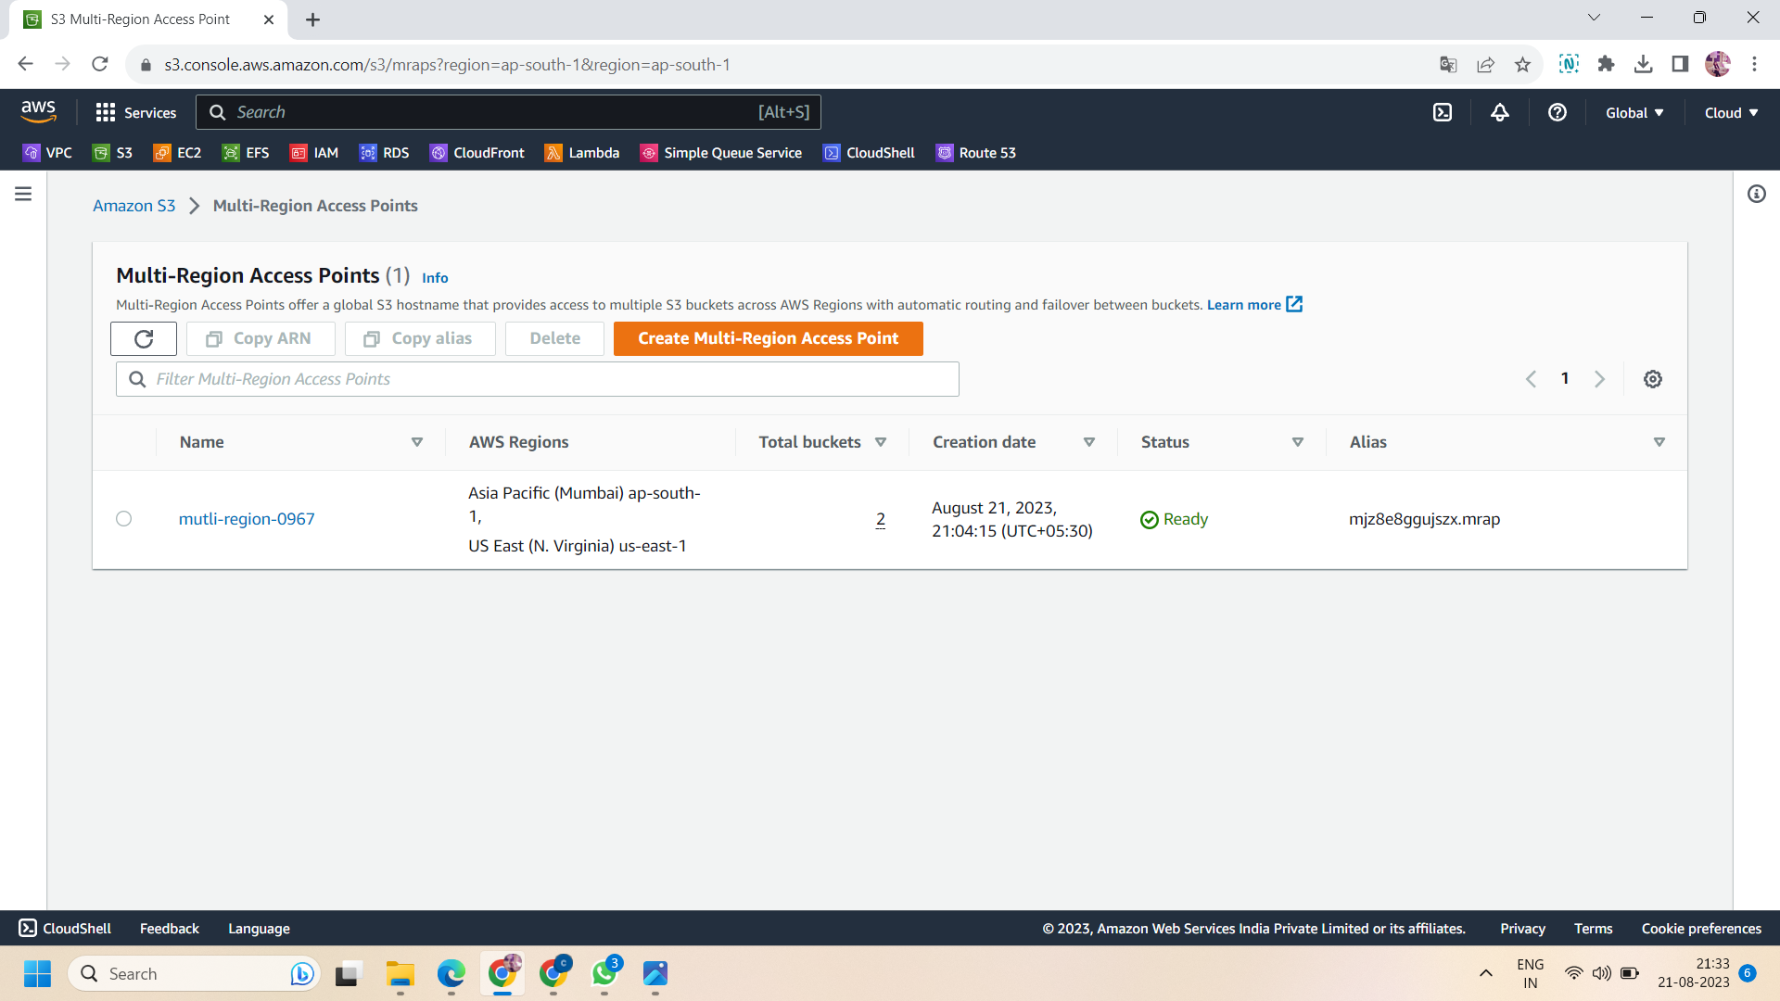

Step 6: in the multi-region access point,go to its “replication and failover” and move to “replication rules”.

Step 7: now create a replication rule.To create a replication rule ,click on “create a replication rule” then:

* Choose the template .Here we select the template “ Replicate objects among all specified buckets”.

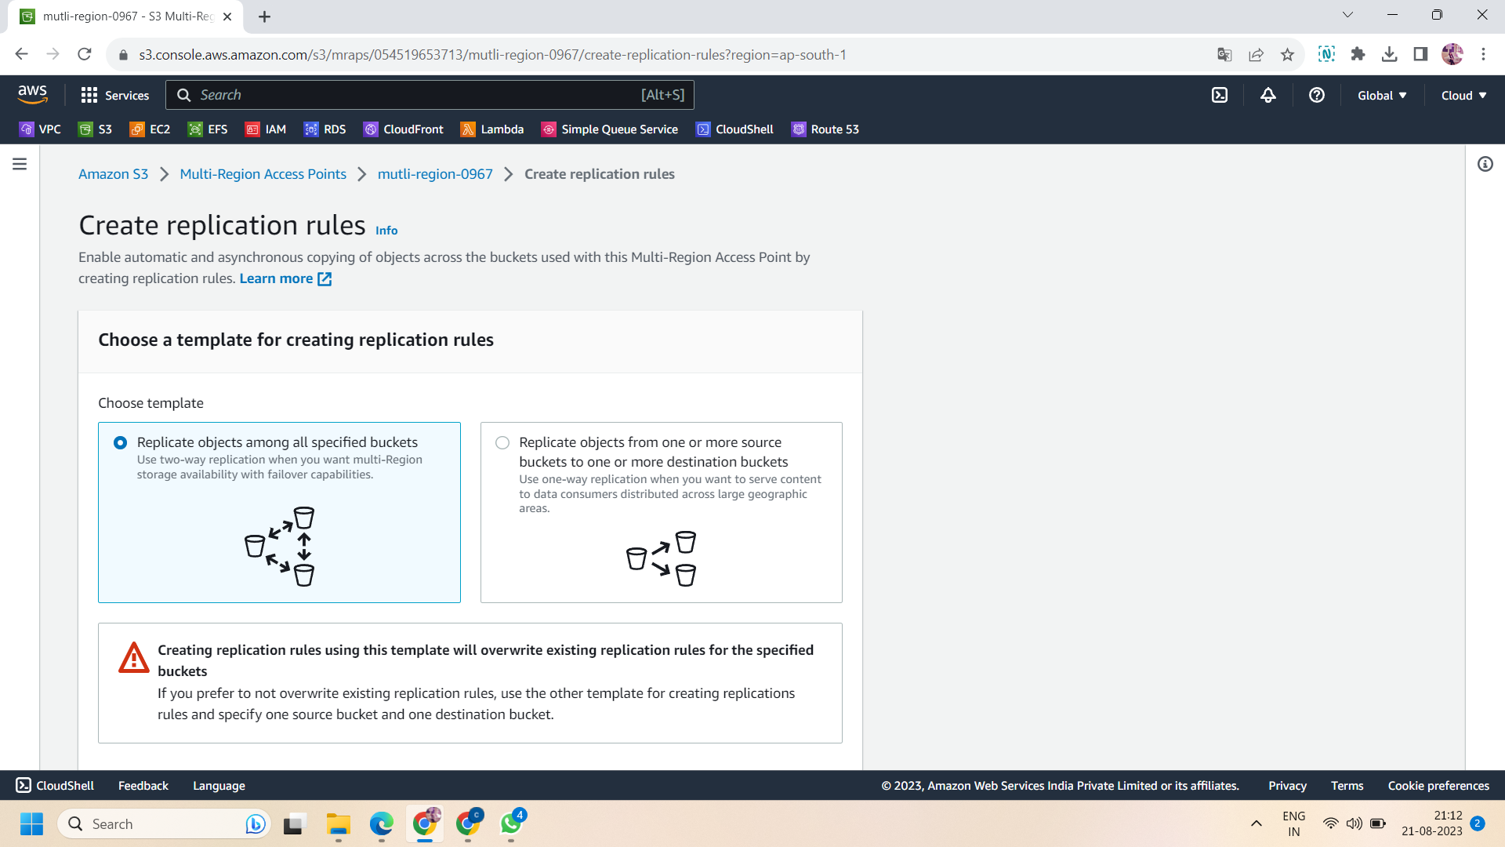

* Then in buckets ,select both the bucket that we create in different regions

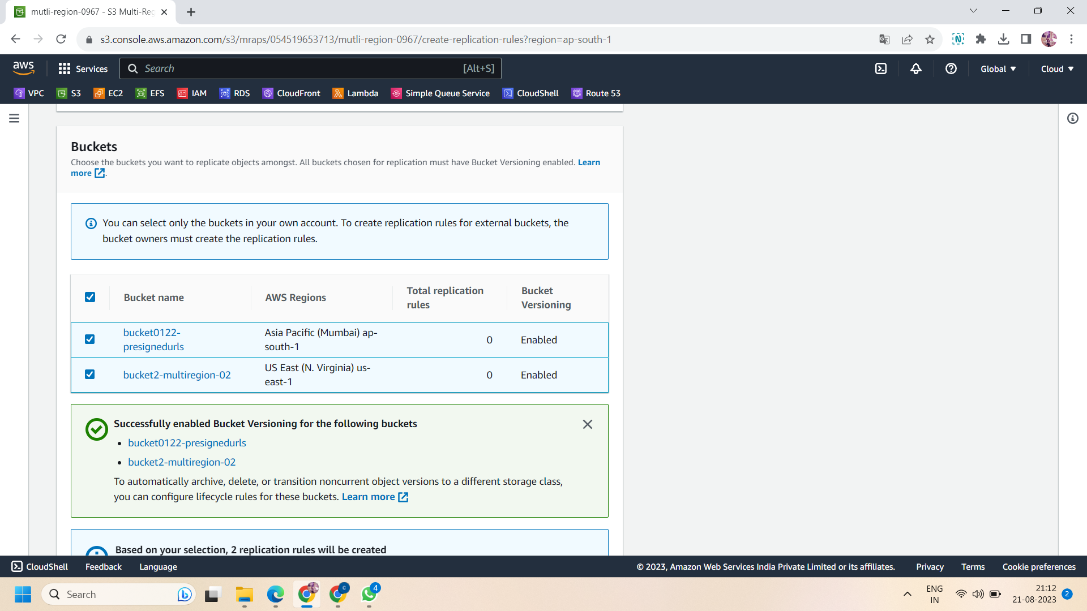

* Then “enable” the bucket versioning of both the buckets
* Enabled the status

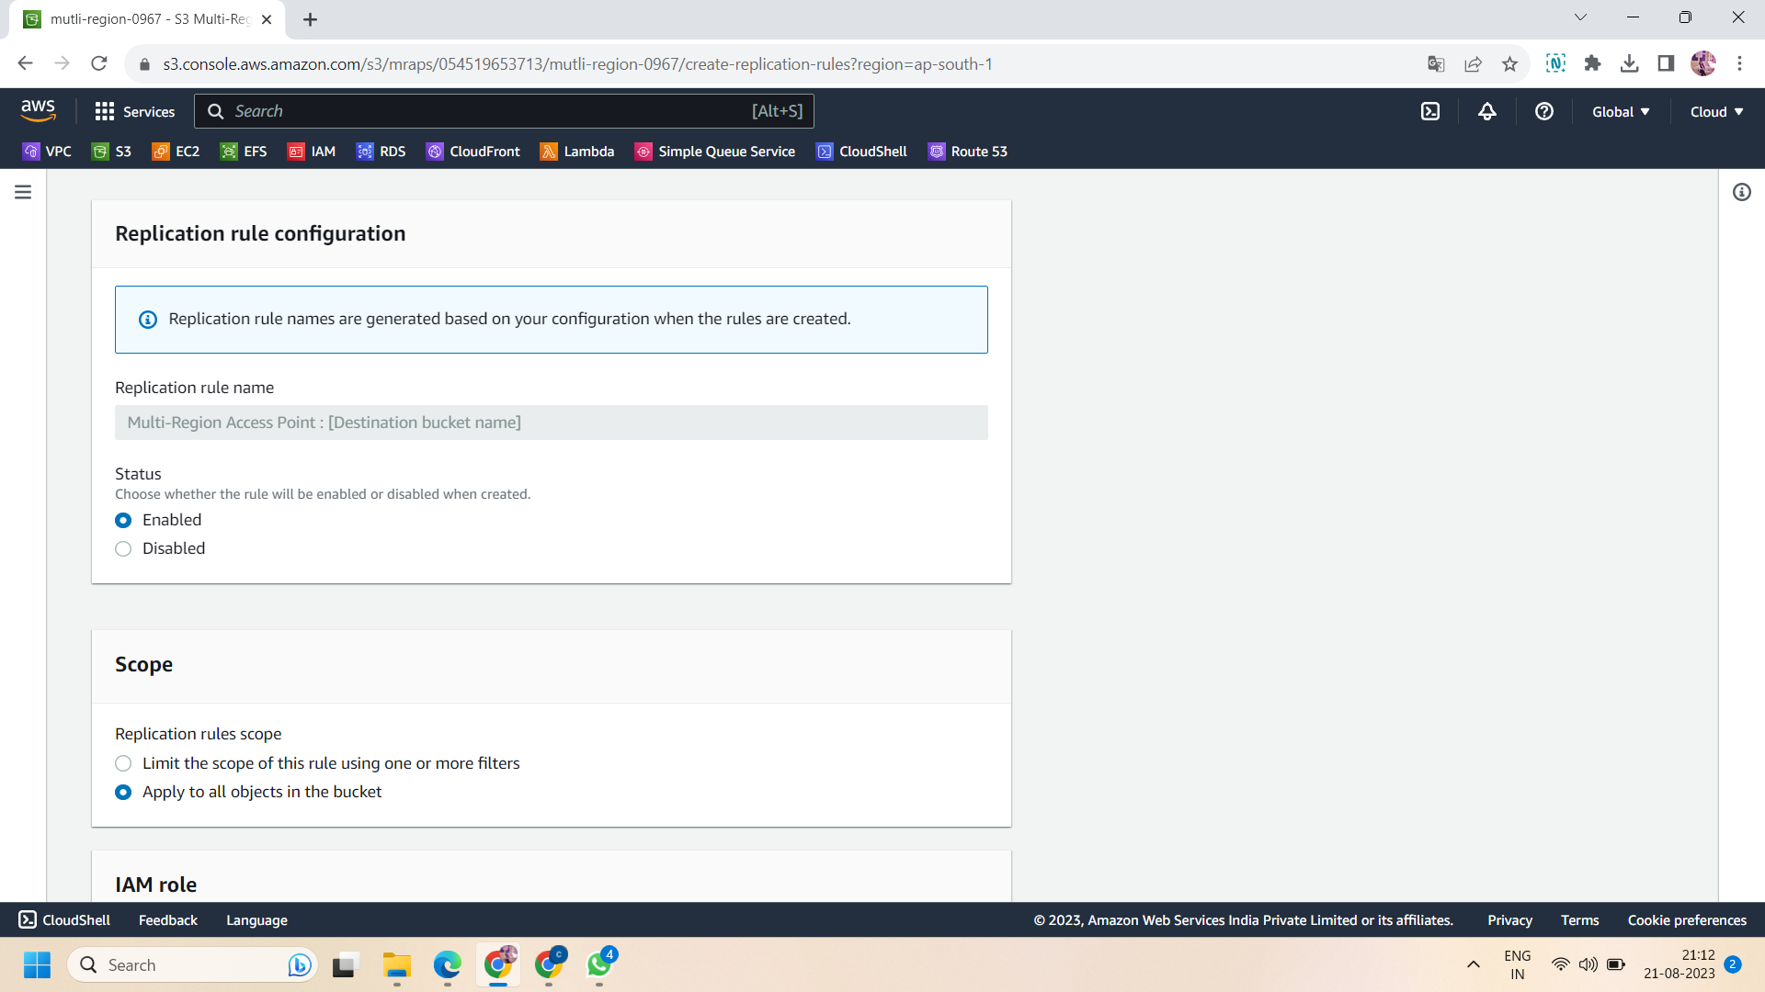

* Select the scope “apply to all objects in the bucket”.

Then leave all the settings by default and then click on “create replication rules”.

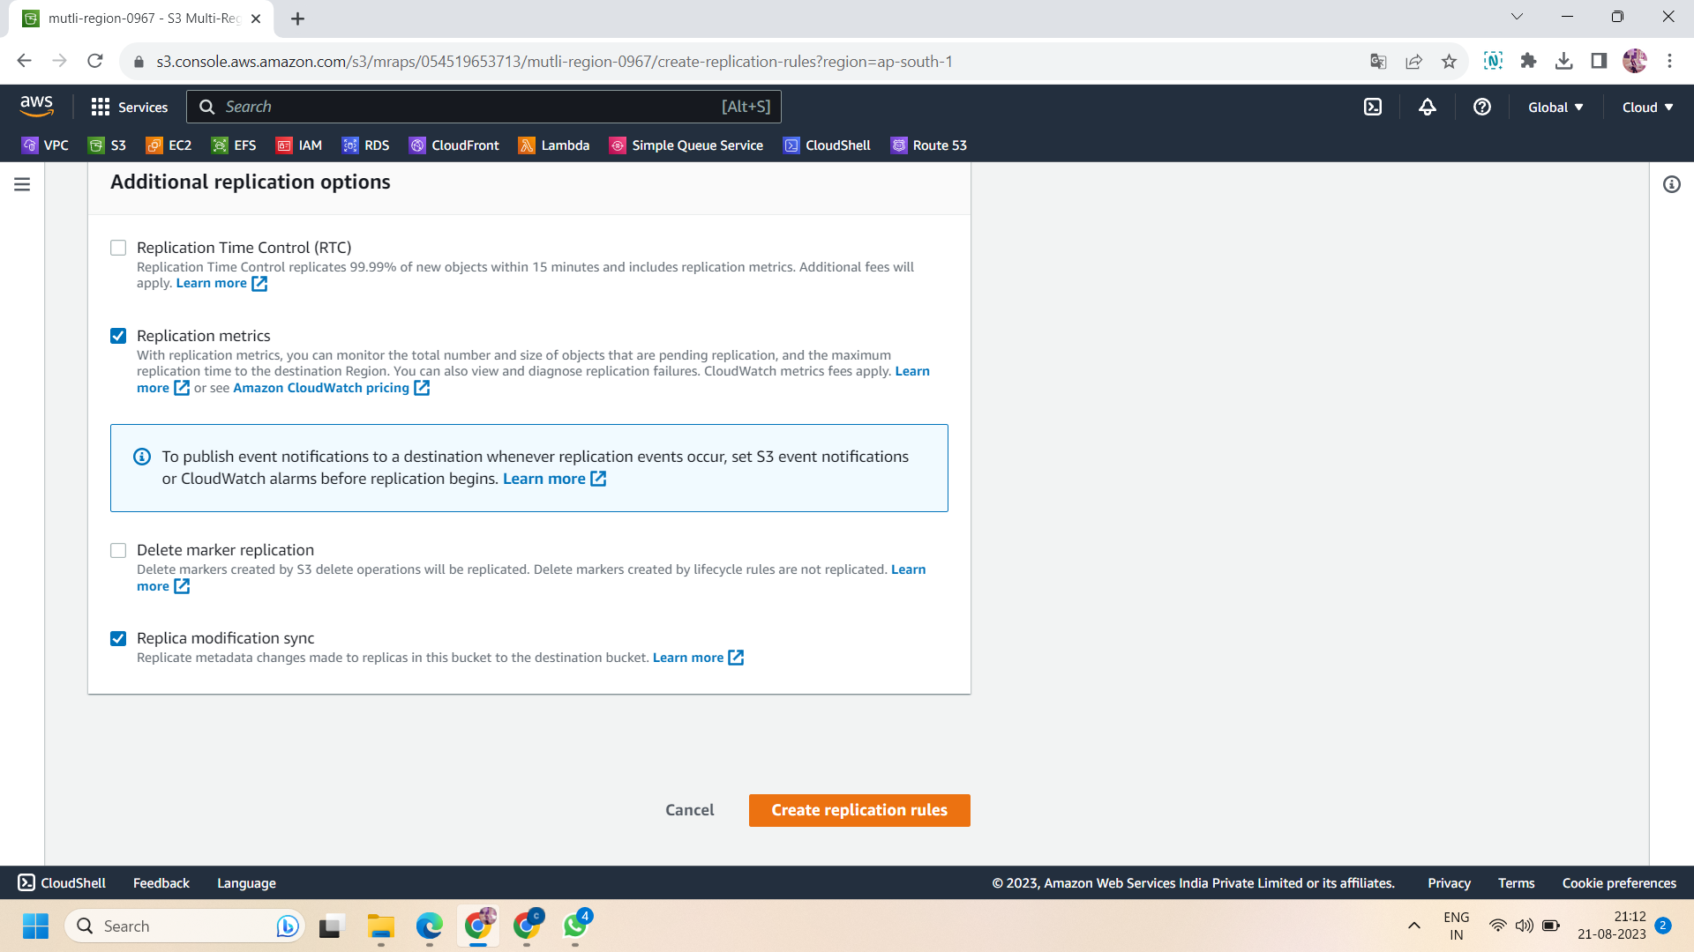

Step 8: then go to “replication and failover overviews” on replication and failover and it will show you the graph connecting both the buckets located at different regions.

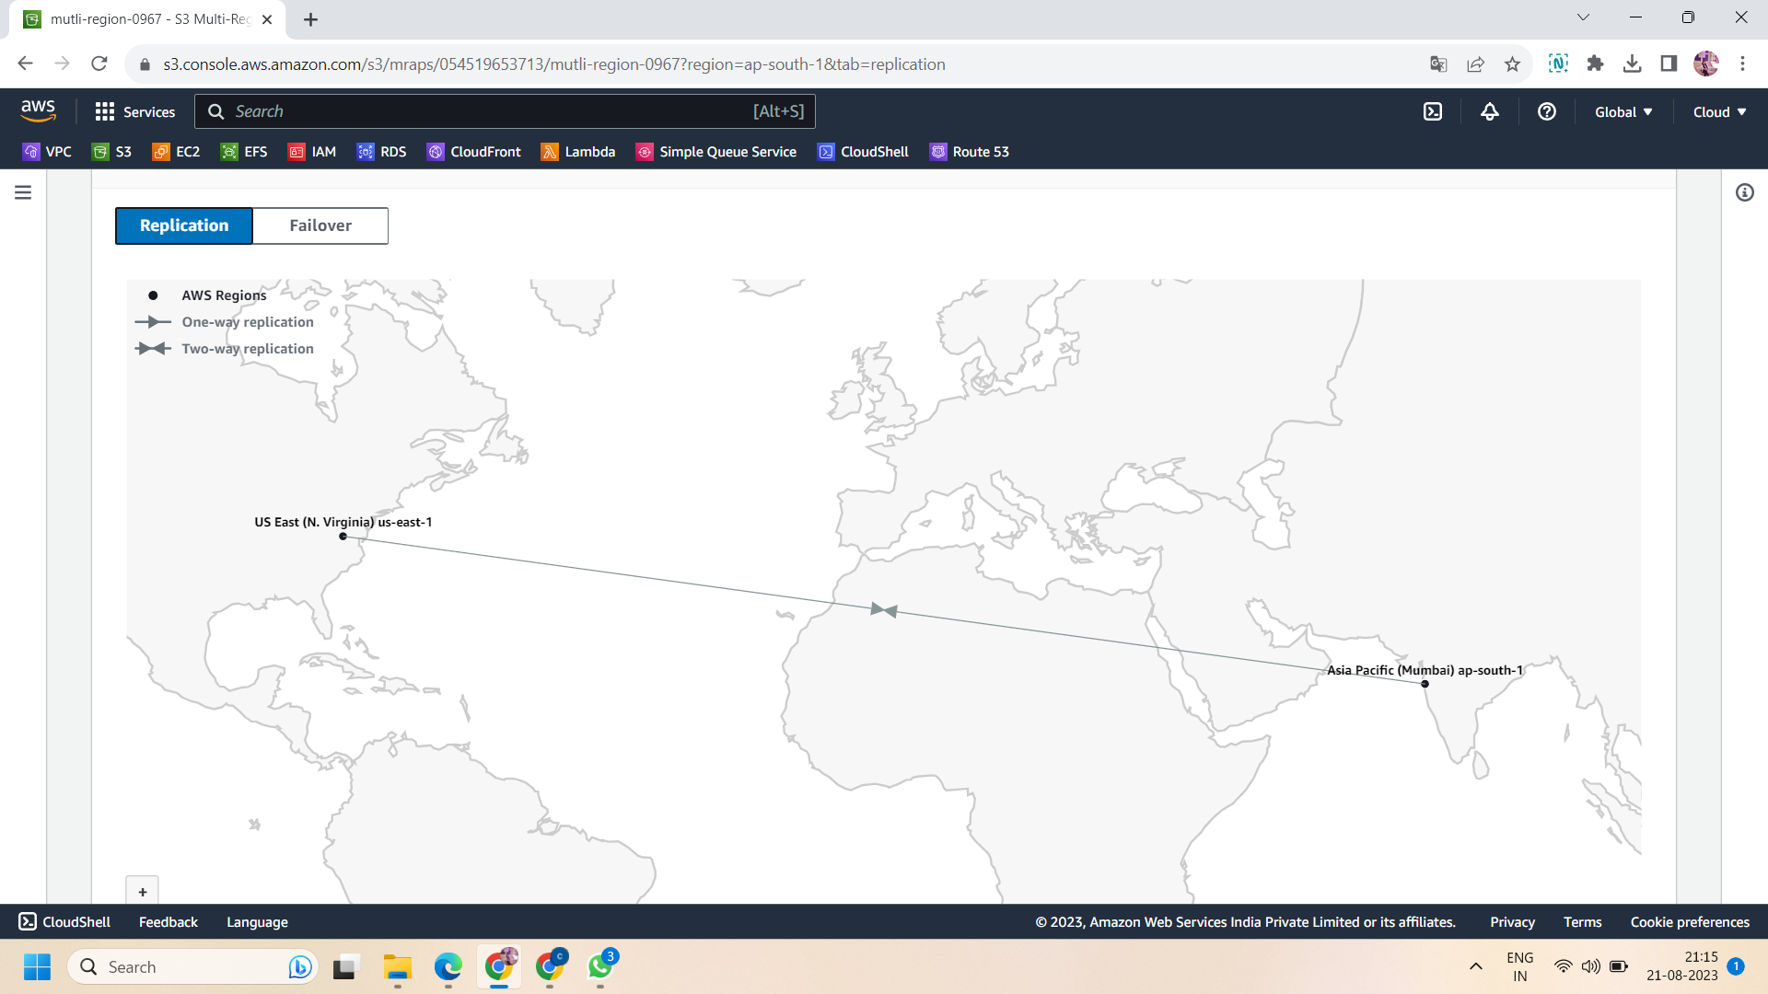

All done!!